***Hands-On Exercise 3.3 [20-points]: Generic Linked List***

### *Instructions:*

***IDE structure:***

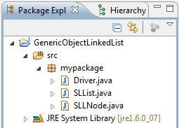

1.❑ Add a SLLNode class and type the code below

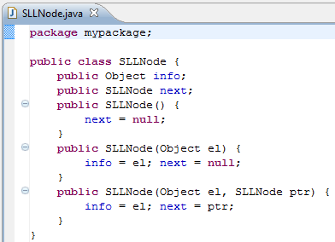

2.❑ Add an IntSLList class and type the code below

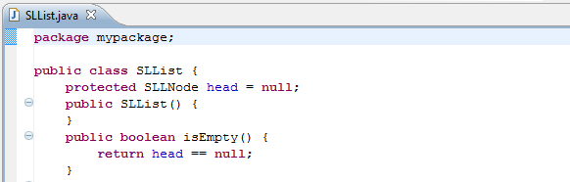

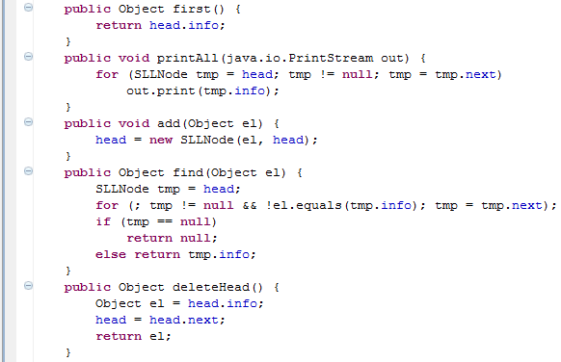

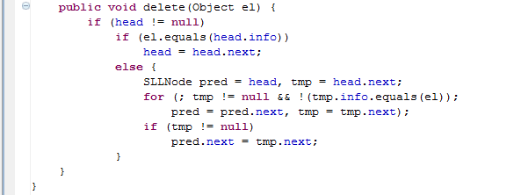

3.❑ Add Driver class and type the code below

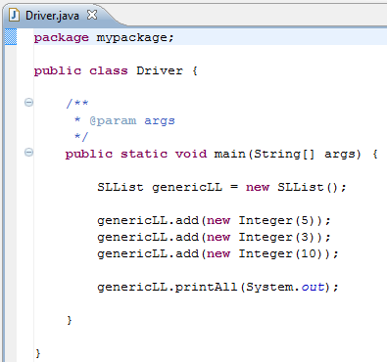

4.❑ Paste your code here.

**package** inclass;

**public** **class** SLLNode {

**public** Object info;

**public** SLLNode next;

**public** SLLNode(){

next = **null**;

}

**public** SLLNode(Object el){

info = el; next = **null**;

}

**public** SLLNode(Object el, SLLNode ptr){

info = el; next = ptr;

}

}

**package** inclass;

**public** **class** SLList {

**protected** SLLNode head = **null**;

**public** SLList(){}

**public** **boolean** isEmpty(){

**return** head == **null**;

}

**public** Object first(){

**return** head.info;

}

**public** **void** printAll(java.io.PrintStream out){

**for**(SLLNode tmp = head; tmp != **null**; tmp = tmp.next)

out.print(tmp.info);

}

**public** **void** add(Object el){

head = **new** SLLNode(el, head);

}

**public** Object find(Object el){

SLLNode tmp = head;

**for**(; tmp != **null** && !el.equals(tmp.info); tmp = tmp.next);

**if**(tmp == **null**)

**return** **null**;

**else** **return** tmp.info;

}

**public** Object deleteHead(){

Object el = head.info;

head = head.next;

**return** el;

}

**public** **void** delete(Object el){

**if**(head != **null**)

**if**(el.equals(head.info))

head = head.next;

**else**{

SLLNode pred = head, tmp = head.next;

**for**(; tmp != **null** && !(tmp.info.equals(el));

pred = pred.next, tmp = tmp.next);

**if**(tmp != **null**)

pred.next = tmp.next;

}

}

}

**package** inclass;

**public** **class** Driver2 {

**public** **static** **void** main(String[] args){

SLList genericLL = **new** SLList();

genericLL.add(**new** Integer(5));

genericLL.add(**new** Integer(3));

genericLL.add(**new** Integer(10));

genericLL.printAll(System.***out***);

}

}

5.❑ Paste your screen shot output here [Ctrl] + [PrtScn]. Make sure you magnified it.

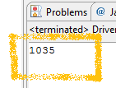Similar to this output

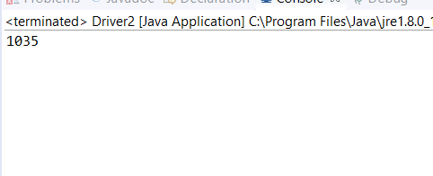

6.❑ Add another node with int value of -12, paste below the code that you added and paste the new output.

genericLL.add(new Integer(-12));

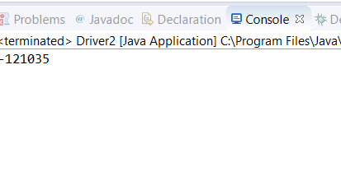

7.❑ Write your topmost question regarding this topic.

8.❑ **Critical Thinking:** If you are asked to make a test question based on this topic, what would be the question and what is your answer?

**Submission Procedure**

1. Write your **name** here: Antonio Isabella
2. Date: 7/31/17
3. **Backup** your work to your USB drive, this material may come out as part of your exam.
4. **Submit** to Blackboard at the link where you got it.

**Note:**

* Submit back to Blackboard where you get it.
* 2-points deduction if you submit it on the wrong place.
* 2-points deduction if you did not follow these instructions.
* Make sure you submit it at the correct location where you got it.

|  |  |  |  |  |
| --- | --- | --- | --- | --- |
| GRADING RUBRIC | | | | |
| Grading Criteria | 3  **Exceeds**  *Excellent*  Epic Wow | 2  **Meets**  *Satisfactory*  O.K. | 1  **Partially Meets**  *Below Expectations*  Not Yet | 0  **Does Not Meet**  *Unacceptable*  Fail |
| **Completeness** | +5-Completed all the required work and added more examples. | +2-Completed all the work required. | +1-Partially completed the work required. | Unfortunately, did not complete the work required. |
| **Coding** | +10- Code is excellent, comments are added, and different techniques were used. | +7-Code is O.K., and program works. | +4-Code works, but still needs improvement. | Unfortunately, no coding. |
| **Output** | +5-Outputs are correct, and provided additional output cases. | +2-Output meets requirement and is readable. | +1-There is output, but not readable, and/or needs improvement. | Unfortunately, no output. |
| **Late** | Excellent, you submitted it before the deadline. | -5, unfortunately for submitting after the deadline. | -7, unfortunately for submitting several weeks after the deadline. | -10, unfortunately, for submitting very late. |